CASE_STUDY (NUMBER -04)---SOLUTION SUBMISSION ON

AZURE ANALYTICS BY

|  |  |
| --- | --- |
| **NAME :** SUPRIYA BHARATHA | **ROLL NO:** DXCAB1211 |
| **BATCH:**DXC-262-ANALYTICS-B12-AZURE | **COMPANY –** DXC TECHNOLOGY |
| **TRAINING UNDER :** MANIPAL PRO LEARN | **TRAINER NAME** – MR. AJAY KUMAR |
| **DATE OF SUBMISSION :** 02-06-2022 | **NO OF TEST CASES** :18 |
| **EMPLOYEE DOMAIN** - AZURE ANALYTICS |  |

# PROBLEM STATEMENT:

Assignment 2nd June 2022:

Global-tech incorporation is leading Biotech & Medical distribution company, has decided to migrate their data warehouse (around volume

of 300TB uncompressed) to Cloud. Also, this organization has decided to migrate all downstream applications to Azure. Since its COVID – pandemic situation, hence its critical time & ETA is very less, the whole migration had to happen seamlessly, Using Azure cloud Service – we have to develop solutions for Global-tech. and migration activity to be performed.

PART - 1:

Table:

emp_id | emp_name | job_name | manager_id | hire_date | salary | commission | dep_id

+ + + + + + + 68319 | KAYLING | PRESIDENT | | 1991-11-18 | 6000.00 | | 1001

66928 | BLAZE | MANAGER | 68319 | 1991-05-01 | 2750.00 | | 3001

67832 | CLARE | MANAGER | 68319 | 1991-06-09 | 2550.00 | | 1001

65646 | JONAS | MANAGER | 68319 | 1991-04-02 | 2957.00 | | 2001

67858 | SCARLET | ANALYST | 65646 | 1997-04-19 | 3100.00 | | 2001

69062 | FRANK | ANALYST | 65646 | 1991-12-03 | 3100.00 | | 2001

63679 | SANDRINE | CLERK | 69062 | 1990-12-18 | 900.00 | | 2001

64989 | ADELYN | SALESMAN | 66928 | 1991-02-20 | 1700.00 | 400.00 | 3001

65271 | WADE | SALESMAN | 66928 | 1991-02-22 | 1350.00 | 600.00 | 3001

66564 | MADDEN | SALESMAN | 66928 | 1991-09-28 | 1350.00 | 1500.00 | 3001

68454 | TUCKER | SALESMAN | 66928 | 1991-09-08 | 1600.00 | 0.00 | 3001

68736 | ADNRES | CLERK | 67858 | 1997-05-23 | 1200.00 | | 2001

69000 | JULIUS | CLERK | 66928 | 1991-12-03 | 1050.00 | | 3001

69324 | MARKER | CLERK | 67832 | 1992-01-23 | 1400.00 | | 1001

**THE CASES :**

case 33: From the following table, write a SQL query to find those employees of department id 3001 or 1001

and joined in the year 1991. Return complete information about the employees

case 34: From the following table, write a SQL query to find those employees who are working for the department ID 1001 or 2001.

Return complete information about the employees

case 35: From the following table, write a SQL query to find those employees whose designation is ‘CLERK’ and work in the department ID 2001.

Return complete information about the employees.

case 36:From the following table, write a SQL query to find those employees who are either CLERK or MANAGER.

Return complete information about the employees

case 37:From the following table, write a SQL query to find those employees who joined in any year except the month of February.

Return complete information about the employees

case 38:From the following table, write a SQL query to find those employees who joined in the year 91.

Return complete information about the employees

case 39:From the following table, write a SQL query to find those employees who joined in the month of June 1991.

Return complete information about the employees

case 40: From the following table, write a SQL query to find all the employees whose annual salary is

within the range 24000 and 50000 (Begin and end values are included.). Return complete information about the employees.

case 41:From the following table, write a SQL query to find all those employees who have joined on 1st May, 20th Feb, and 3rd Dec in the year 1991.

Return complete information about the employees.

case 42:From the following table, write a SQL query to find those employees working under the managers 63679 or 68319 or 66564 or 69000.

Return complete information about the employees

case 43:From the following table, write a SQL query to find those employees who joined after the month JUNE in the year 1991

and within this year. Return complete information about the employees

case 44:From the following table, write a SQL query to find those employees who joined in 90's.

Return complete information about the employees

case 45: From the following table, write a SQL query to find those managers who are in the department 1001 or 2001.

Return complete information about the employees.

case 46: From the following table, write a SQL query to find those employees who joined in the month FEBRUARY with a salary range

between 1001 to 2000 (Begin and end values are included.). Return complete information about the employees

case 47: From the following table, write a SQL query to find those employees who joined before or after the year 1991.

Return complete information about the employees.

case 48: From the following tables, write a SQL query to find employees along with department name. Return employee ID,

employee name, job name, manager ID, hire date, salary, commission, department ID, and department name

case 49: From the following tables, write a SQL query to find those employees who earn 60000 in a year or not

working as an ANALYST. Return employee name, job name, (12*salary) as Annual Salary, department ID, and grade

case 50:From the following table, write a SQL query to find those employees whose salary is higher than the salary of their managers.

Return employee name, job name, manager ID, salary, manager name, manager's salary.

Please create a word / pdf document, and send it to : [avyuktitraining1@gmail.com](mailto:avyuktitraining1@gmail.com)

# INTRODUCTION

This is a case study given by manipal pro learn team on the basis of the training done in the forenoon session of this morning. The main objective behind this case study is to work on industry- based problems and achieve solutions for the solutions.

The problem statement have ten cases and these are of easy to moderately difficult level. All the cases have been focused on what the trainer taught in the earlier sessions. Basic operations in the data using SQL are performed that include :

* CREATE
* INSERT
* UPDATE
* SELECT

Along with some more interesting cases.

This case study gives me immense confidence in mastering the domain that has been assigned to me. The queries have been highlighted with green color and later the snap shot of the output is attached.

# SOLUTIONS :

**CASE 33:**

SELECT *

FROM globetechtb231

WHERE to_char(HIRE_DATE,'YYYY') = '1991'

AND (DEP_ID =3001

OR DEP_ID =1001) ;

# OUTPUT:

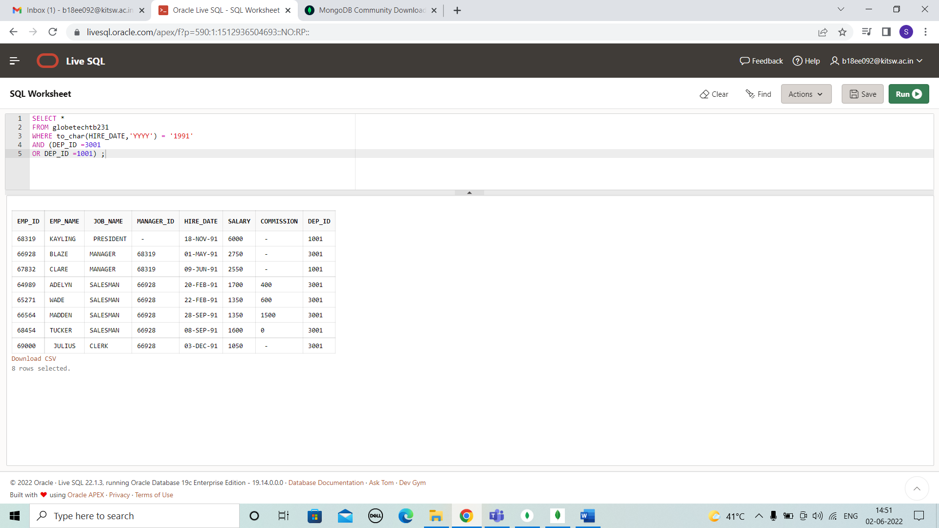

**CASE 34:**

SELECT *

FROM globetechtb231

WHERE (DEP_ID =2001

OR DEP_ID =1001) ;

# OUTPUT:

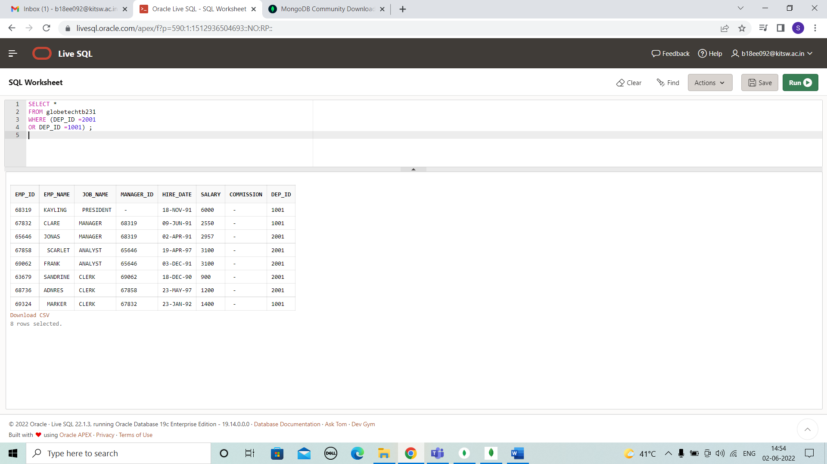

**CASE 35;**

SELECT *

FROM globetechtb231

WHERE (JOB_NAME='CLERK' AND DEP_ID =2001);

# OUTPUT:

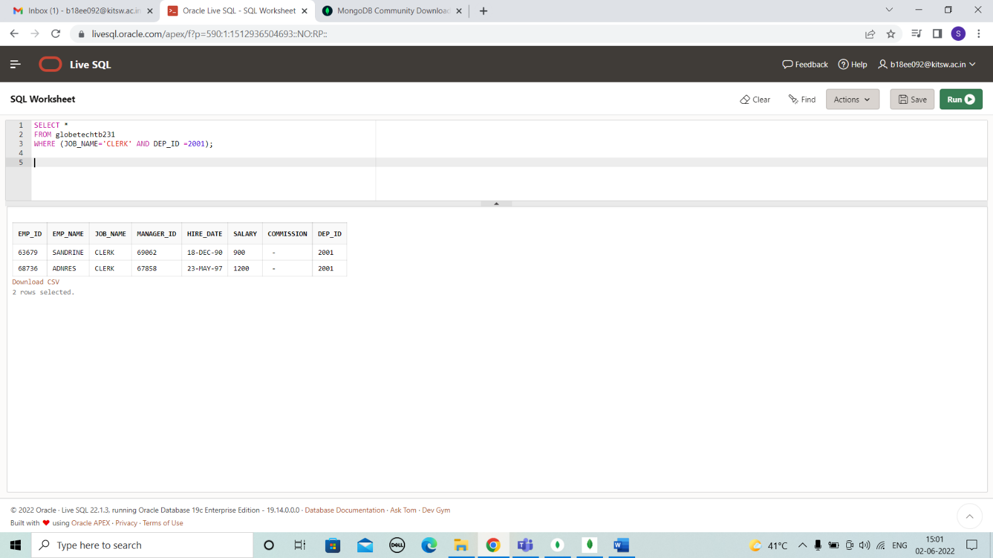

**CASE 36:**

SELECT *

FROM globetechtb231

WHERE (JOB_NAME='CLERK' OR JOB_NAME='MANAGER');

**OUTPUT:**

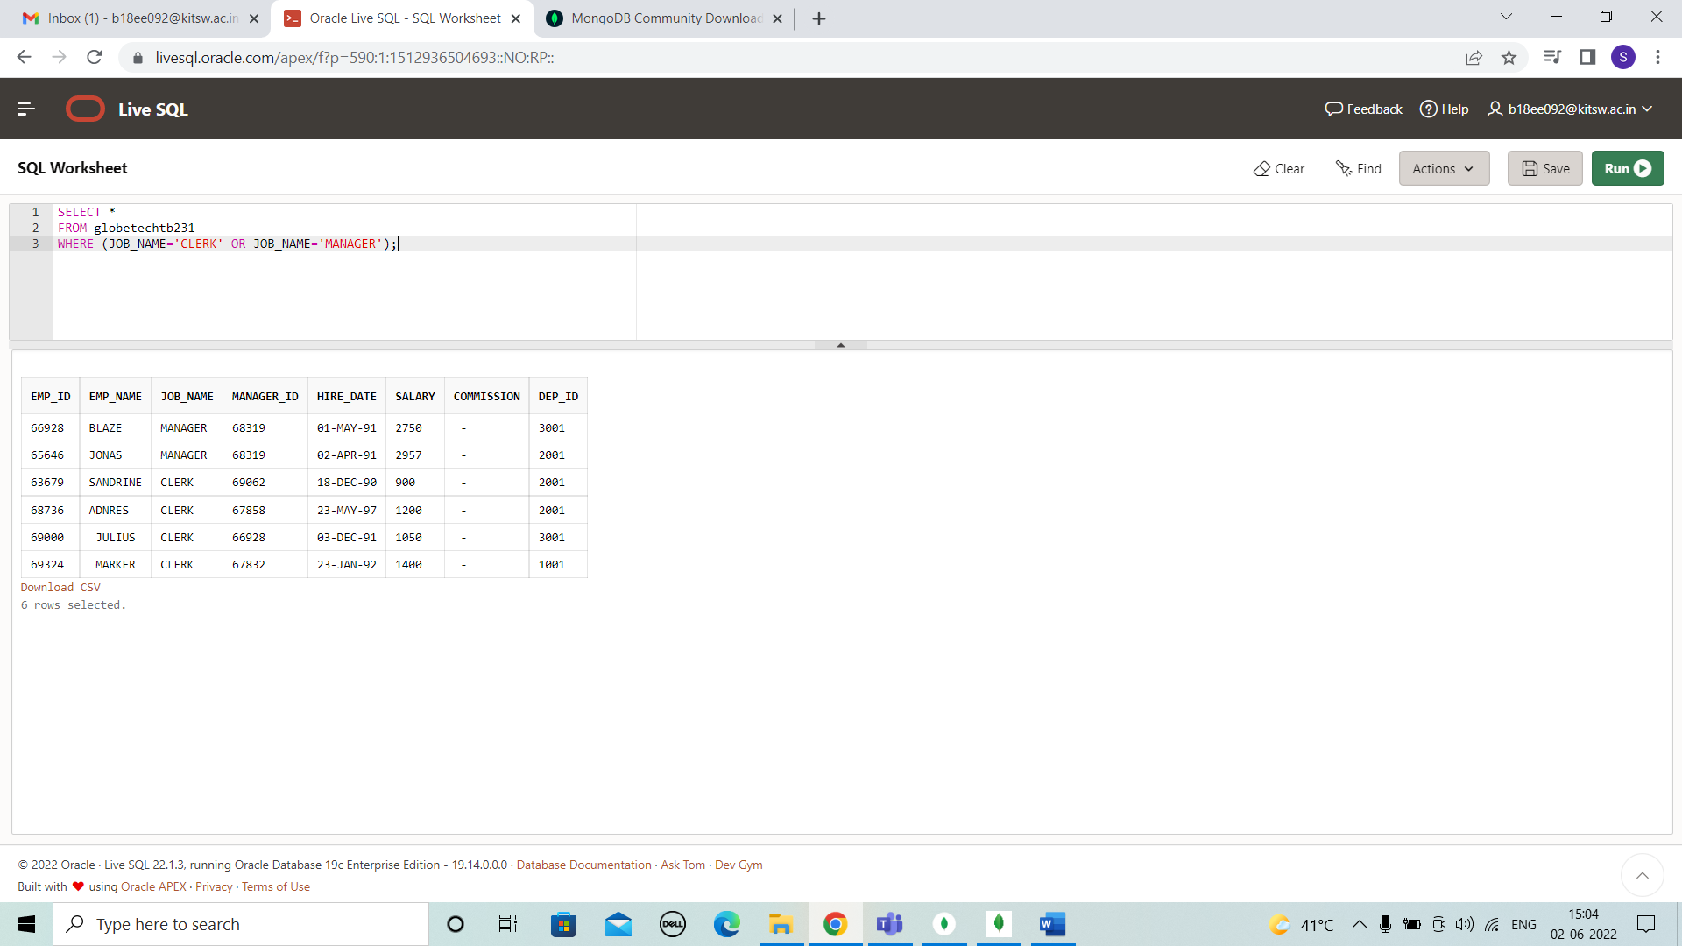

# CASE 37:

SELECT *

FROM globetechtb231

WHERE to_char(hire_date,'MONTH') NOT LIKE 'FEB%';

# OUTPUT:

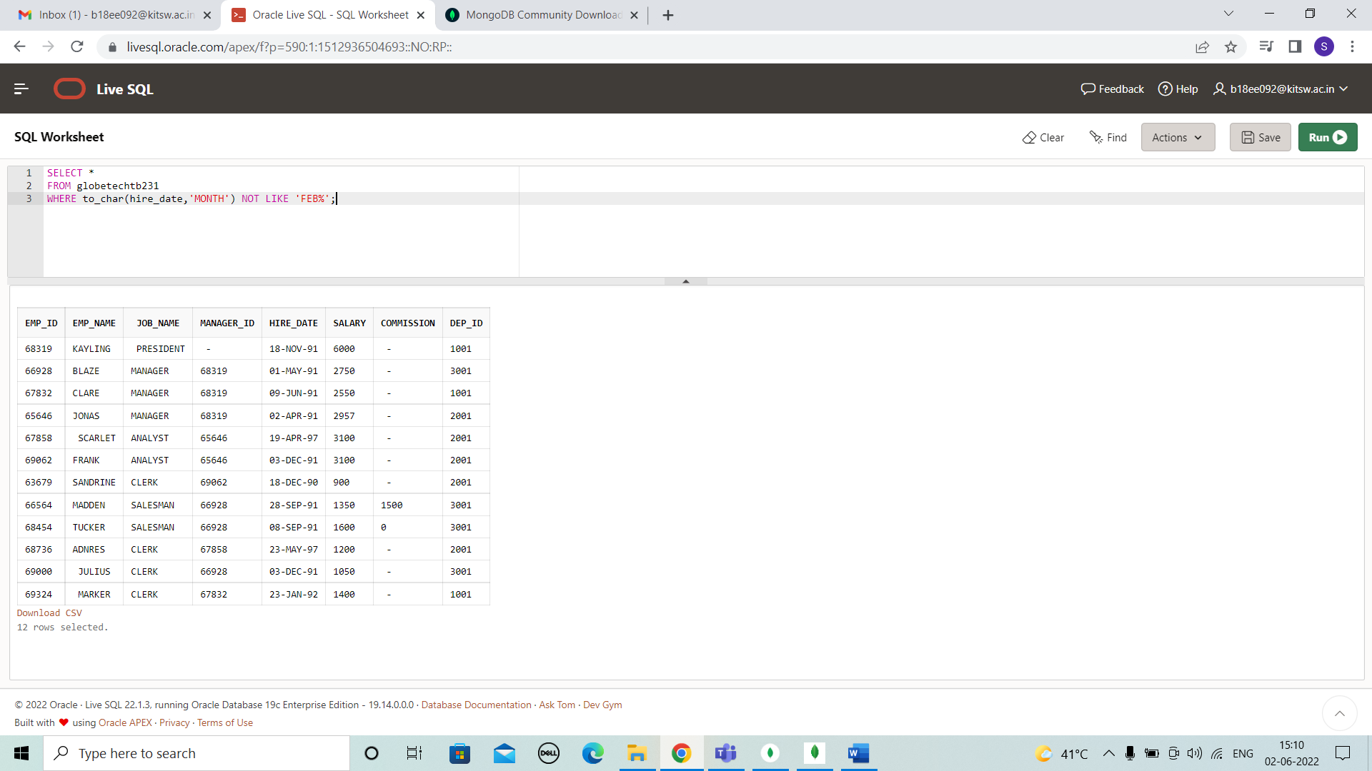

**CASE 38:**

SELECT *

FROM globetechtb231

WHERE to_char(hire_date,'YYYY')=1991;

# OUTPUT:

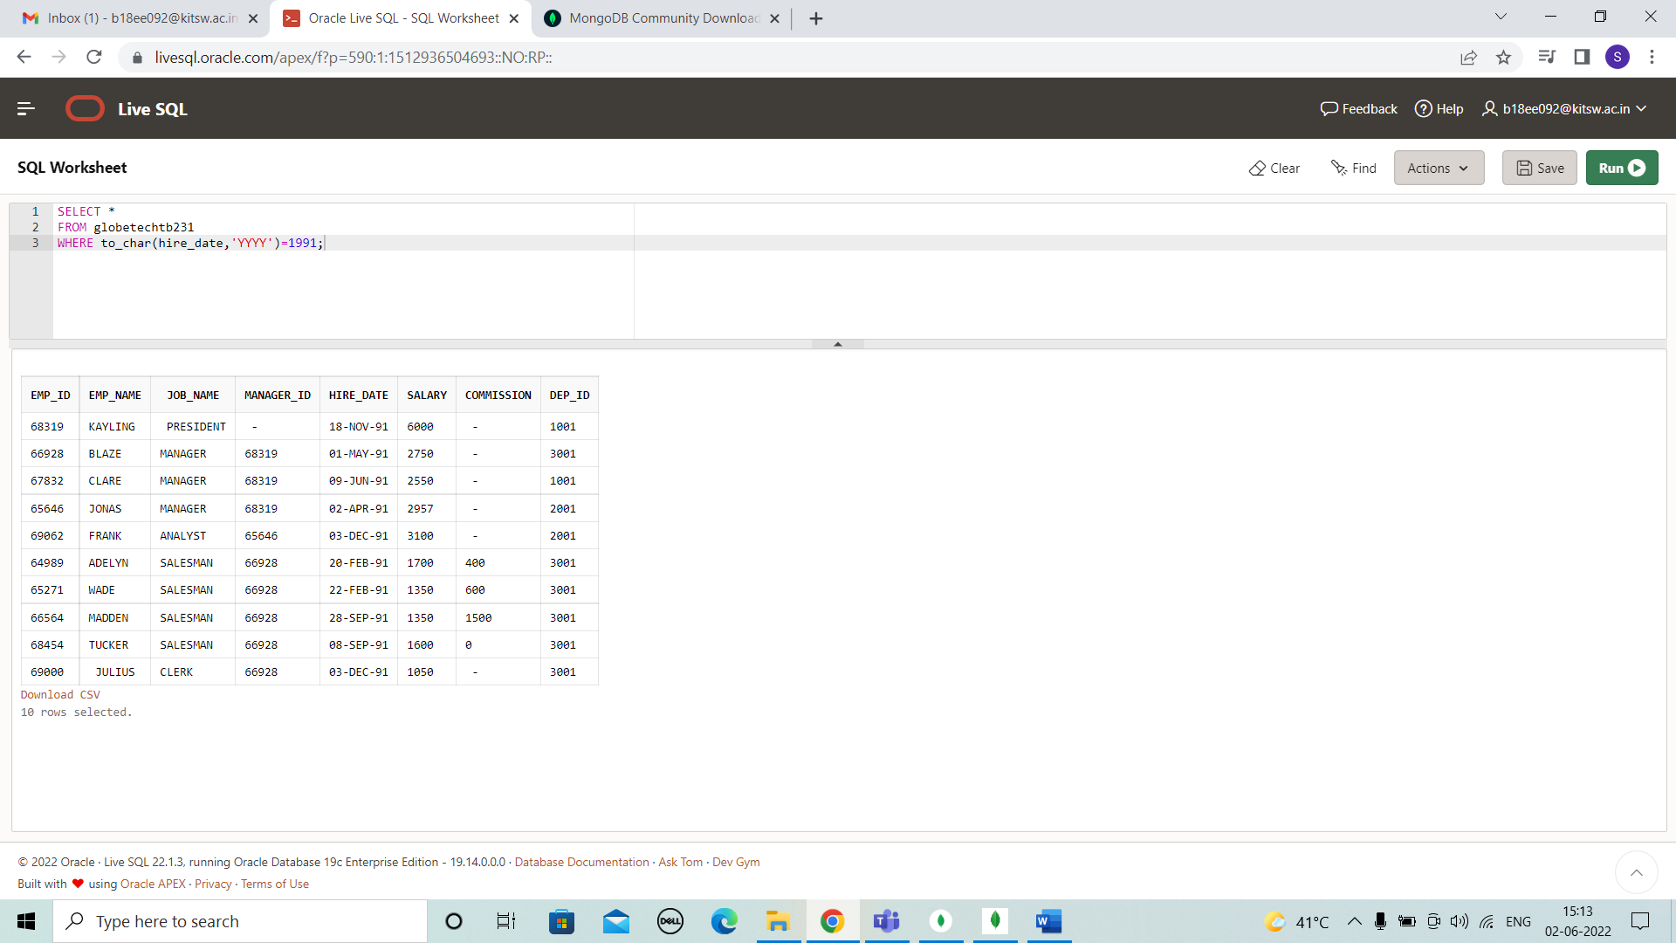

**CASE 39:**

SELECT *

FROM globetechtb231

WHERE to_char(hire_date,'MONTH') LIKE 'JUN%'AND

to_char(hire_date,'YYYY')=1991;

**OUTPUT:**

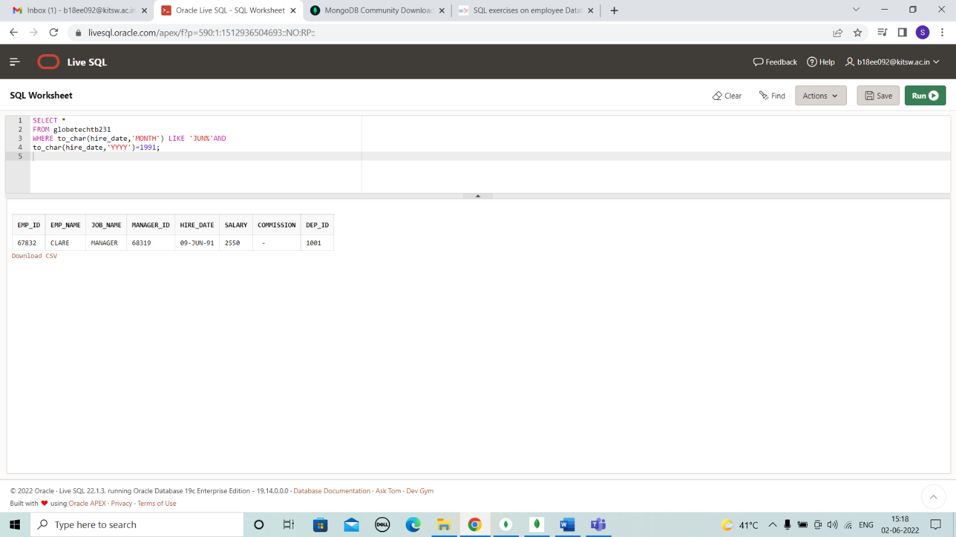

# CASE 40 :

SELECT *

FROM globetechtb231

WHERE 12*salary BETWEEN 24000 AND 50000;

# OUTPUT:

# 

# CASE 41:

SELECT *

FROM globetechtb231

WHERE to_char(hire_date,'DD-MON-YY') IN ('01-MAY-91', '20-FEB-91', '03-DEC-91');

**OUTPUT:**

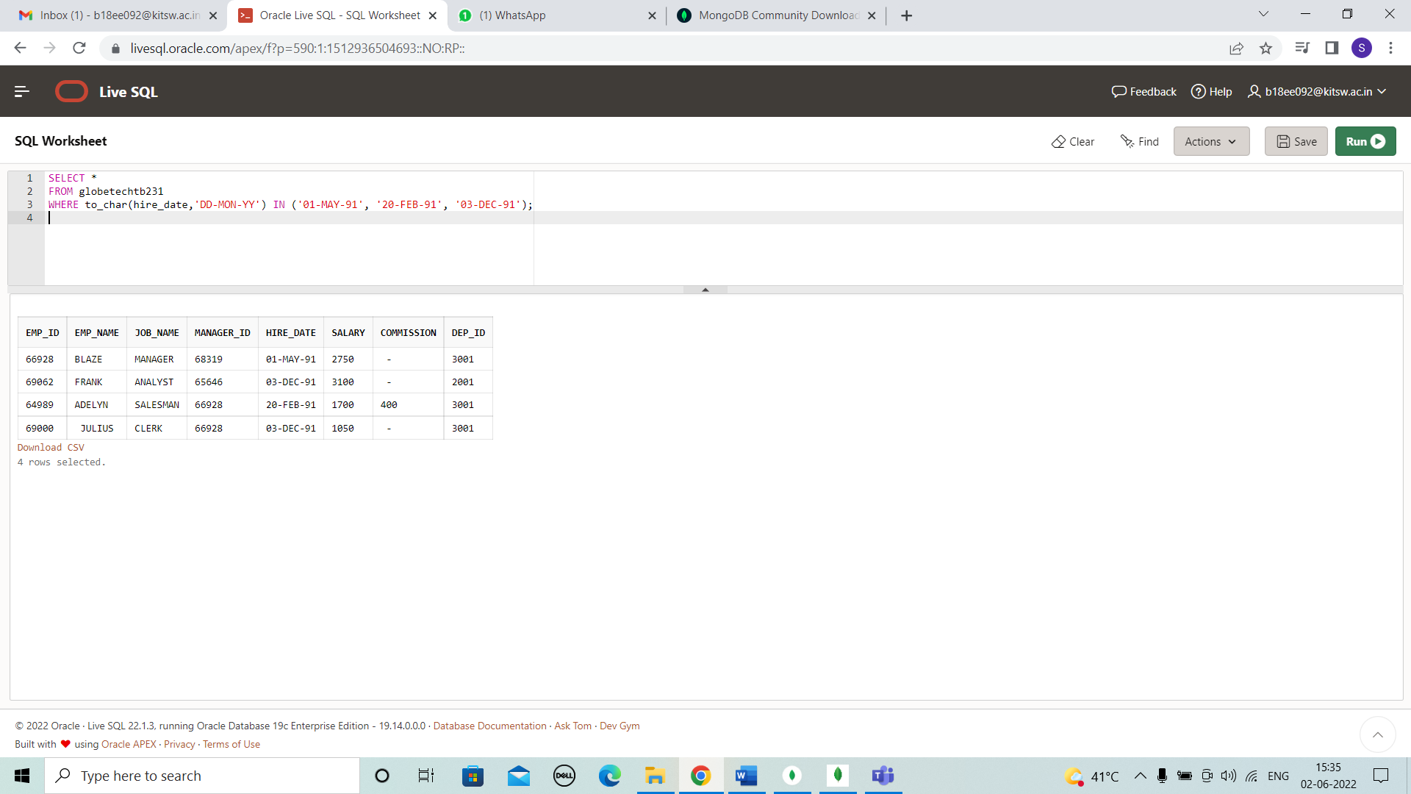

# CASE 42:

SELECT *

FROM globetechtb231

WHERE MANAGER_ID IN (63679,

68319,

66564,

69000);

# OUTPUT:

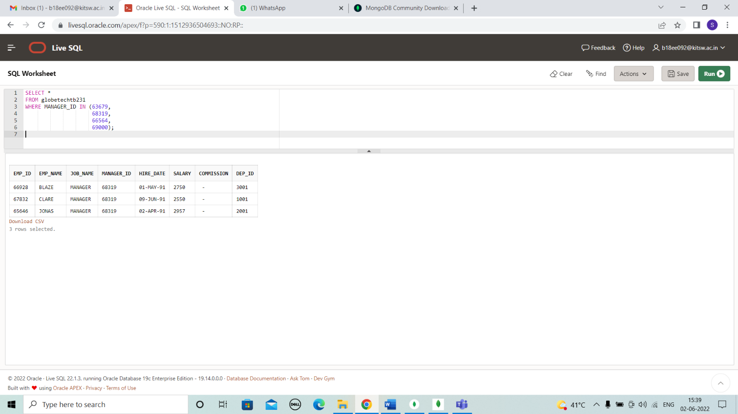

**CASE 43:**

SELECT *

FROM globetechtb231

WHERE HIRE_DATE BETWEEN '01-JUL-91' AND '31-DEC-91';

# OUTPUT:

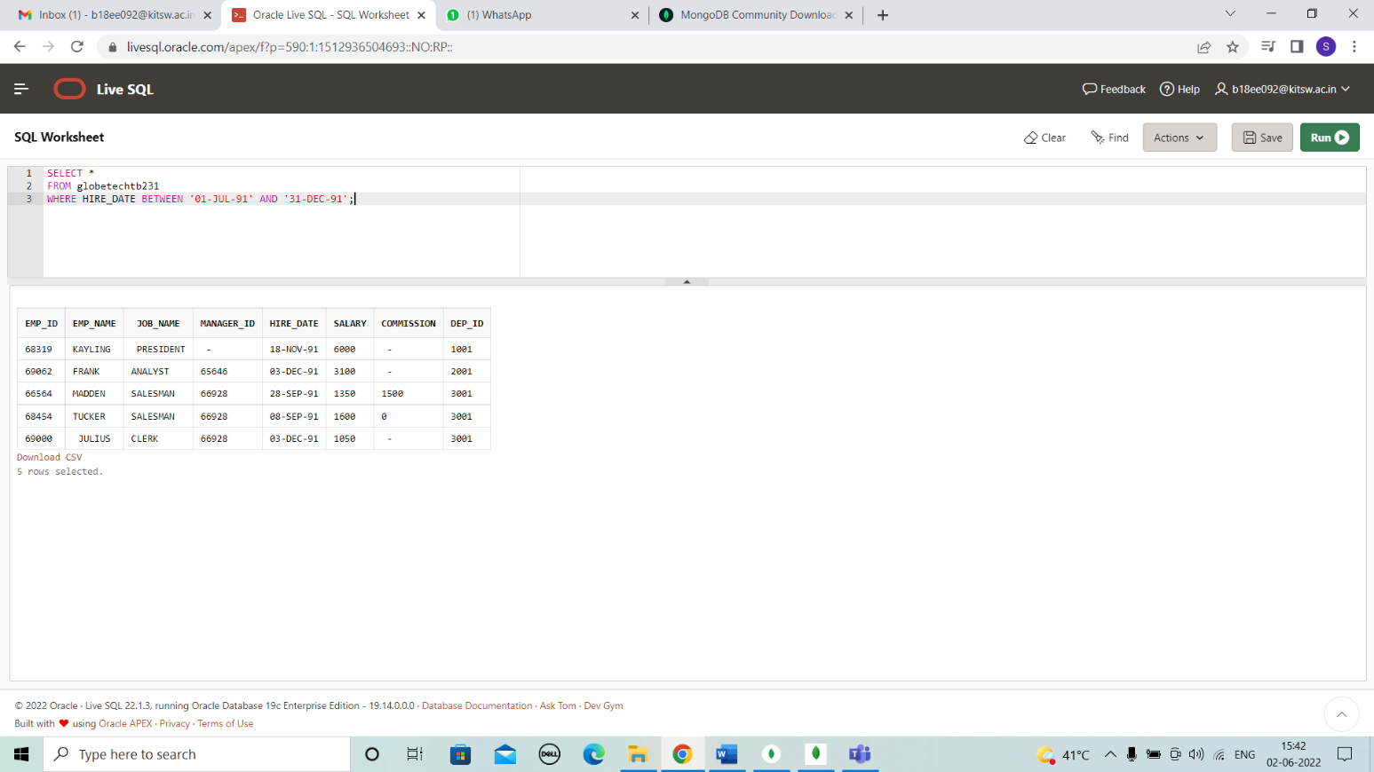

**CASE 44:**

SELECT *

FROM globetechtb231

WHERE to_char(hire_date,'YYYY') BETWEEN '1990' AND '1999';

# OUTPUT:

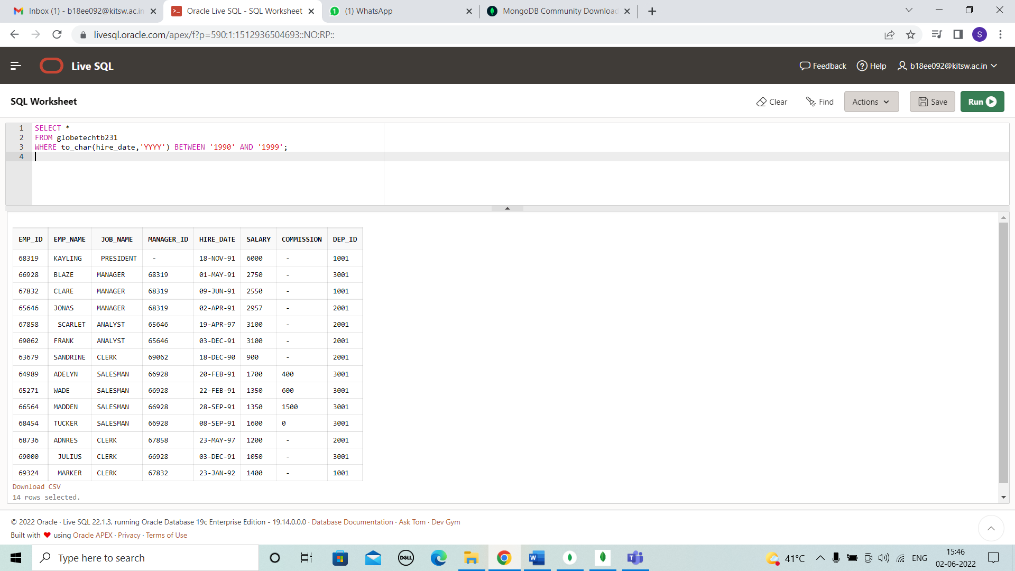

**CASE 45:**

SELECT *

FROM globetechtb231

WHERE (dep_id = 1001 OR dep_id =2001) AND job_name = 'MANAGER';

# OUTPUT:

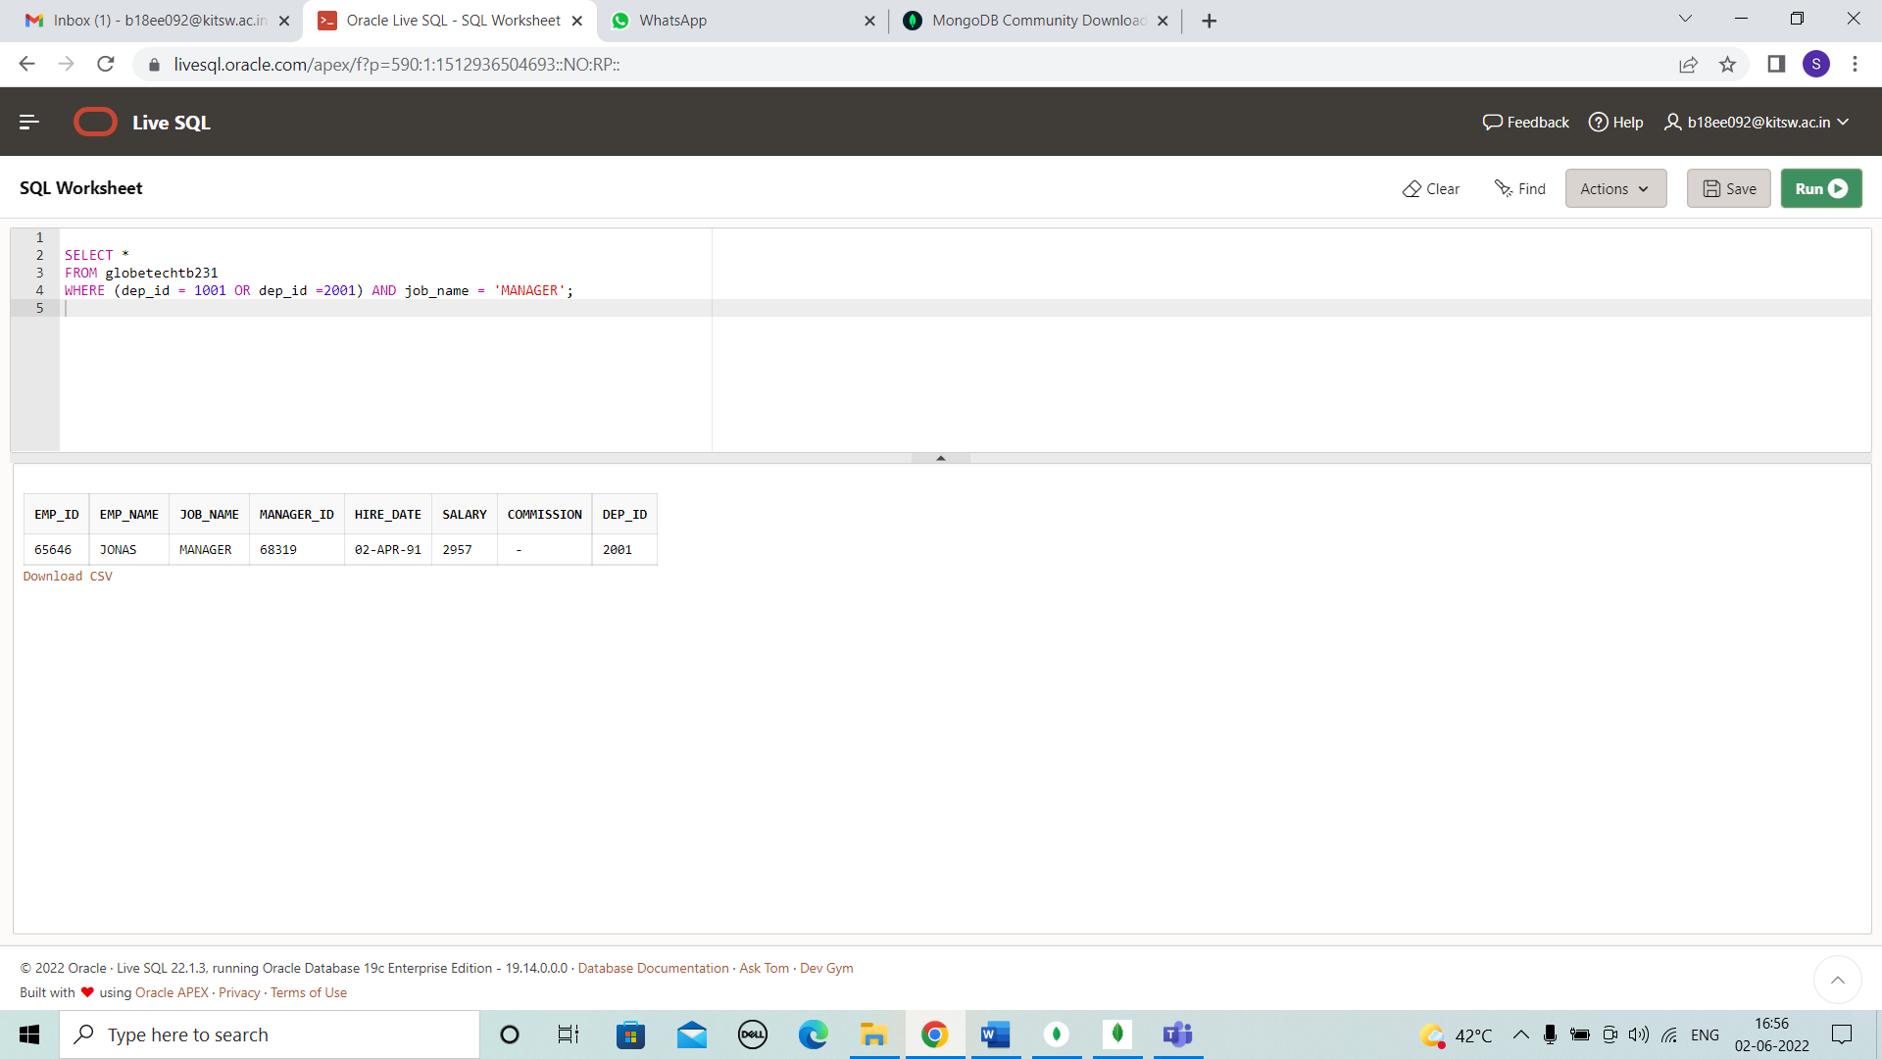

**CASE 46:**

SELECT *

FROM globetechtb231

WHERE to_char(hire_date,'MON') = 'FEB'

AND salary BETWEEN 1000 AND 2000;

# OUTPUT:

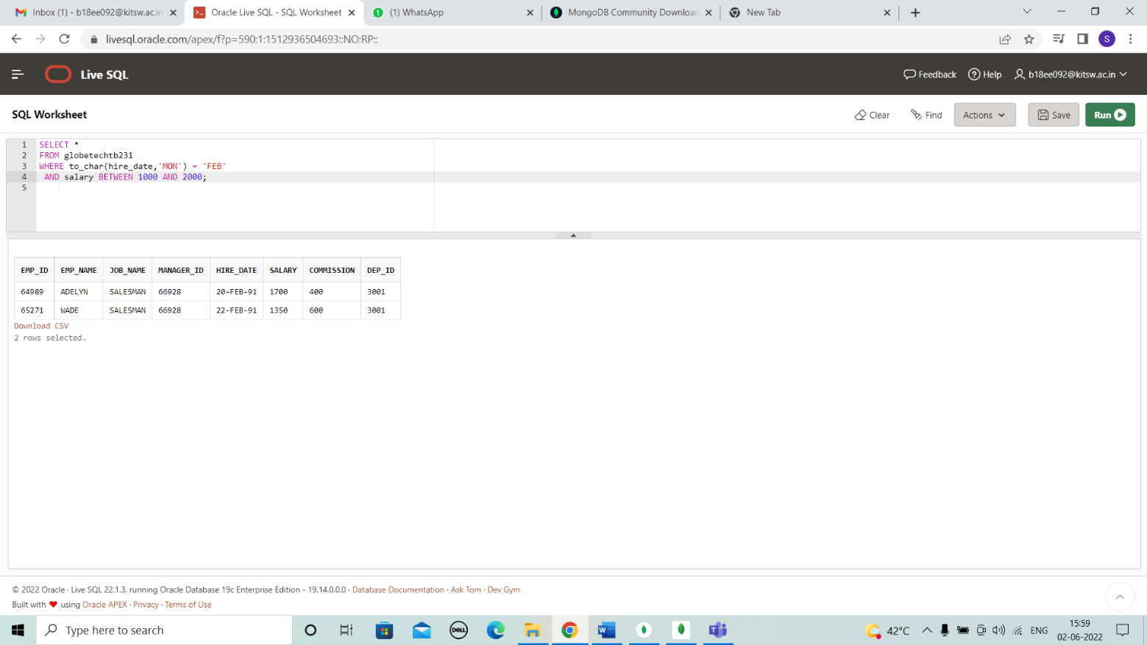

**CASE 47:**

SELECT *

FROM globetechtb231

WHERE HIRE_DATE < ( DATE '1991-1-1');

# OUTPUT:

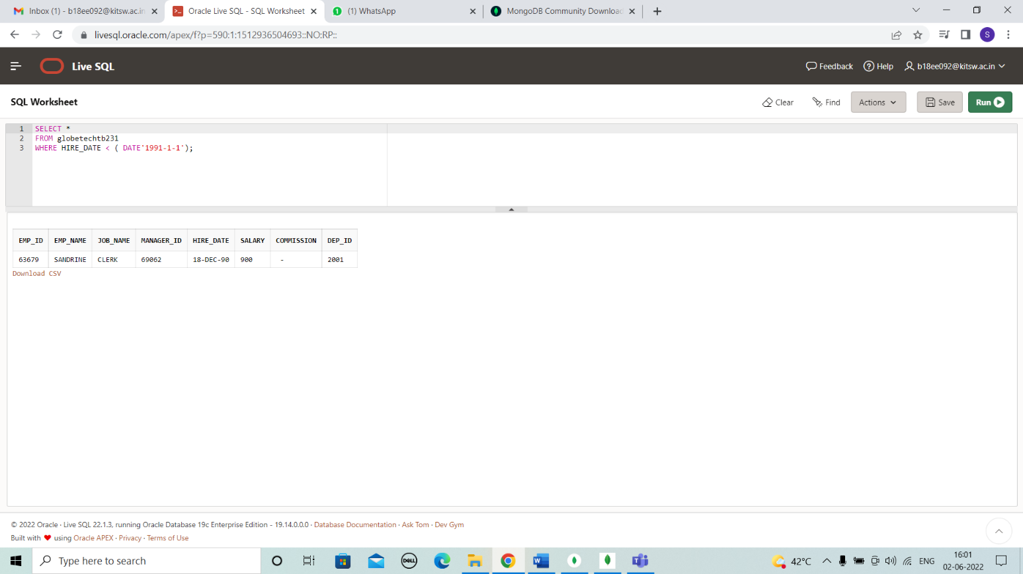

**CASE 50:**

SELECT w.emp_name,

w.job_name,



w.manager_id,

w.salary,

m.emp_name "Manager",

m.emp_id,

m.salary "Manager_Salary"

FROM globetechtb231 w,

globetechtb231 m

WHERE w.manager_id = m.emp_id

AND w.salary > m.salary;

# OUTPUT:

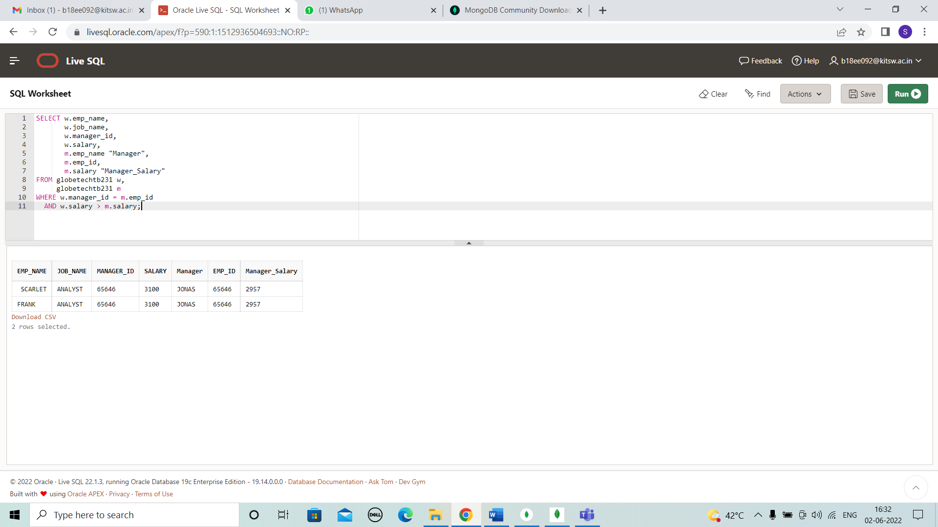

# RESULT

All the test cases have been solved and presented successfully in the present document.

# CONCLUSIONS

All the case studies have been solved successfully with all the concepts that have been covered in the training session. It’s really a great experience of learning while solving the cases. This case study gave me immense confidence regarding my ability to upskill in new technologies.

# REFERENCES

* https://[www.w3schools.com/sql/sql_count_avg_sum.asp](http://www.w3schools.com/sql/sql_count_avg_sum.asp)